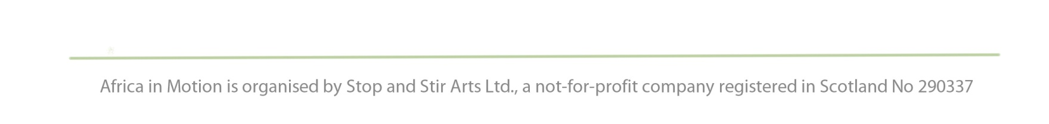
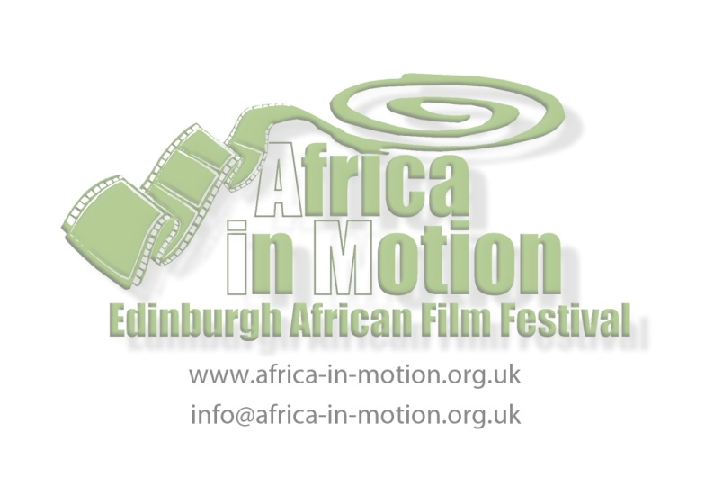
PRESS RELEASE
For immediate use: Monday 17 October 2011

Filmmaker's Seminar @ ECA: Obi Emelonye talks Nollywood
On Thursday 3 November, Africa in Motion (AiM) film festival welcomes acclaimed Nigerian filmmaker Obi Omelonye to Edinburgh. This day of events begins with the screening of his new feature film, The Mirror Boy. The screening will conclude with a discussion with the director before we walk up to Edinburgh College of Art for Emelonye's Filmmaker Seminar.
Film Screening: The Mirror Boy
Nigeria - Obi Emelonye - Nigeria 2010 - 1h27 - HDV - U - Fiction
Thu 3 Nov, 10am
Filmhouse Cinema 2
£2.60 (www.filmhousecinema.com / 0131 228 268)
Filmmaker's Seminar
Thu 3 Nov, 2.00pm to 3.00pm
Room 017, Edinburgh College of Art,
Lauriston Place, Edinburgh EH3 9DF
Free non-ticketed event
On Obi Emelonye
Nigerian director Obi Emelonye will be presenting this seminar talking about his filmmaking experiences, and in particular his recent award-winning fiction film, The Mirror Boy , which he wrote, directed and co-produced. Produced by The Nollywood Factory and OH Films, The Mirror Boy features some of Africa’s biggest film stars and is an example of a recent African feature film incorporating Nollywood stylistics while remaining accessible to both African and international audiences.
Obi is one of the brightest creative minds to come out of Nollywood. Born in Nigeria and based in the UK, Obi’s films have been shown in European cinemas since 2004. Obi has a multi-disciplinary approach to filmmaking with directorial credits including: Echoes of War (2004), The London Successor (2006), Lucky Joe (2006), The Asylum (2008), Quiet Storm (2009), and The Mirror Boy (2010). We are very excited to welcome Obi to Africa in Motion and look forward to learning about his filmmaking experiences.

On Nollywood
The emergence of Nollywood is a tale of African cinema and specifically depicts positive movements for an African film market. However, the study of this industry is intriguing and applicable to all filmmakers. Nollywood filmmaking actively captures 'the story'. The fast pace and low maintenance nature of this type of filmmaking enables the filmmaker to capture the essence of a narrative instantaneously. This workshop will introduce you to new possibilities in filmmaking and offer an affordable and effective mode of storytelling for independent and documentary filmmakers, whilst also highlighting alternative modes of distribution enabled by this kind of filmmaking.
Established in the 1990s as a commercial alternative to the traditional Francophile cinema based in Ouagadougou, Nollywood is based in English-speaking Africa, specifically Nigeria. It was initiated by Nigerian natives who discovered the ability to quickly produce films on hand-held video recorders. In contrast to traditional African cinema, Nollywood films are widely considered to better depict African traditions, partly in relation to their dominant themes (religion, fidelity, witchcraft), and partly due to being produced entirely by African actors, filmmakers and editors.
The phenomenon of Nollywood is based on alternative production values: one film is created in a matter of weeks, costing approximately $20,000. As a result, Nigerian directors produce between 500 and 1,000 movies a year. As this mode of film is very popular, it has developed a $250 million industry in one of the world's poorest countries. Emelonye will discuss in detail the stigma attached to Nollywood as a consequence of these peculiar production values and the effects that this is having on developing African film markets.

After the seminar
Following Emelonye's seminar, AiM is screening two social documentaries. These screenings are free and non-ticketed. Zambian filmmaker, Penelope Machipi, and Matthieu Bron from Mozambique address differing social obstables in their respective countries.
Hidden Truth - UK Premiere
Penelope Machipi · Zambia 2011 · 21m · English and Bemba with English subtitles · 15
3pm - Room 017, Edinburgh College of At
De corpo e alma (Body and Soul) - UK Premiere
Matthieu Bron · Mozambique 2011 · 56m · Portuguese with English subtitles · 15
3.30pm - Room 017, Edinburgh College of Art

Notes:

Tickets for all festival screenings and events available from the Filmhouse Box Office (0131 228 2688; www.filmhousecinema.com)

For full programme information, see the website: www.africa-in-motion.org.uk

For more information about Africa in Motion Filmmaker’s Seminar and publicity images, please contact Gillian Cook at gillian@africa-in-motion.org.uk or call 07790 200 471.

