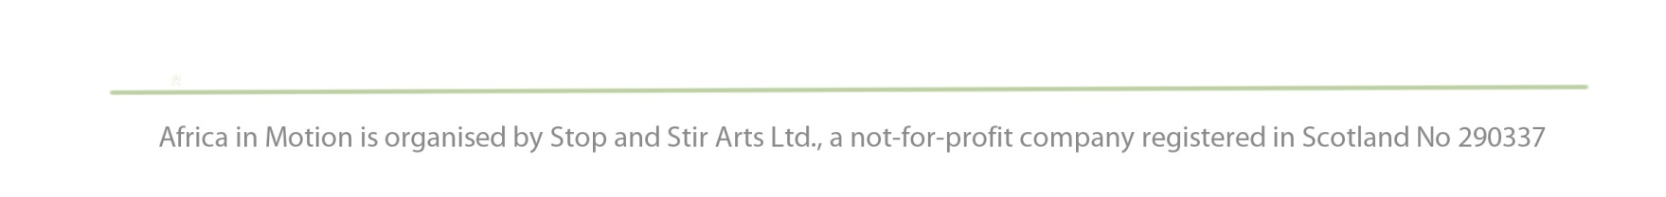
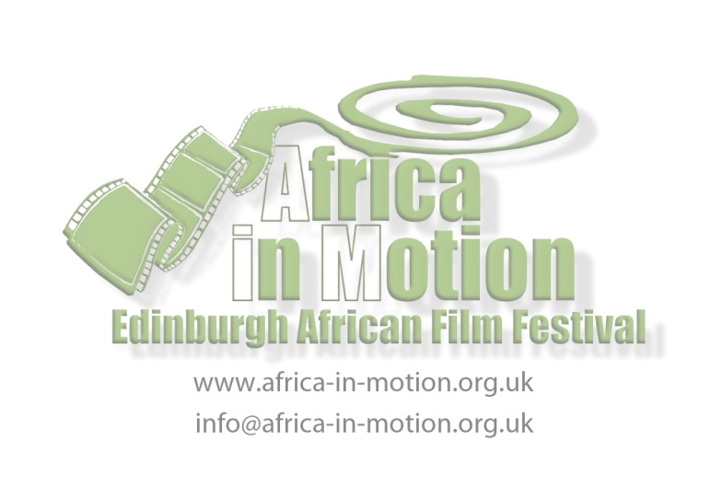
PRESS RELEASE
For immediate use: Wednesday 19 October 2011

Africa in Motion (AiM) Short Film Competition:
Seven Stunning Films from across Africa

Friday 4 November 2011, 5.45pm
Filmhouse Cinema, 88 Lothian Road, Edinburgh

Africa in Motion (AiM), one of the UK's largest African film festivals, reveals this year's entries for its popular short film competition, now in its fourth year. Seven stunning films from across the continent compete for this prestigious prize, sponsored this year by The Africa Channel. The films will be shown on Friday 4 November at Filmhouse cinema in Edinburgh at 5.45pm.

The short film competition is geared towards 'young and emerging' African filmmakers (who have not produced feature-length films yet); this year's shortlisted films deal with themes ranging from myths and folktales, families and relationships, to mysterious powers and the magic of storytelling. They reflect the exciting young filmmaking talent in Africa today, particularly in countries which may not have an established film-making industry such as Mozambique and Ethiopia. As in previous years, the shortlisted films in AiM's Short Film Competition, reveal new talent and names to look out for in the future.

In these short films we see how African filmmakers continue to address serious and relevant social issues (such as religious fundamentalism, enviromental protection and domestic abuse) and how the scope of the genre is expanding through more films experimenting with style and narrative.

The winner of the Short Film Competition will be selected by a jury of international film specialists and will be announced directly after the screenings. The audience will also get a chance to vote for their favourite film, The Audience Choice Award, and the winner of this contest will be announced at the closing screening of the festival on 6 November.

Commenting on the quality of this year's selection, Noe Mendelle, Director of Scottish Documentary Institute and one of the short film competition judges said:
'The short list is extremely strong making it quite a challenge to select a winner. The technical standard of production is getting higher and higher. It was also lovely to see countries such as Algeria and Ethiopia represented in the competition.'

For full programme details please visit www.africa-in-motion.org.uk.

Tickets are available from Filmhouse box office on 0131 228 2688 or www.filmhousecinema.com. Concessionary discounts and ticket deals are available.

- ENDS -
Notes to Editors
- The short film competition entrants are:
Lezare (For Today), Zelalem Woldemariam, Ethiopia
Based on an Ethiopian folktale, Lezare is a revealing and touching story about a homeless boy in a small village in southern Ethiopia. This beautifully shot film conveys a powerful message about global warming, environmental protection, poverty and hunger. “A great story...The devastating twist of events at the end gave you much food for thought.” (Zina Saro-Wiwa, AiM Short Film Competition Judge).
- The Tailored Suit, Kitso Lelliott, South Africa
The Tailored Suit tells the story of Mathilda, a young woman in rural South Africa in the 1940s. She dreams of moving to the city, a place of liberation and emancipation, and she discovers a path to the city through an oppressive marriage.
“Beautifully shot, divine lighting...A highly original piece.” (Zina Saro-Wiwa, AiM Short Film Competition Judge).
- Dina, Mickey Fonseca, Mozambique
When 14-year-old Dina falls pregnant, her mother, Fuzia, realises that the violent behaviour of her husband Remance has reached extreme heights.
“Very moving and well-acted...Dina...is a girl very much on the cusp. Still a child but also growing up fast.” (Zina Saro-Wiwa, AiM Short Film Competition Judge).
- Garagouz, Abdenour Zahzah, Algeria
Mokhtar earns his living as a puppeteer with the help of his son and protégé. Using his old van, he travels between the few schools scattered across the expansive Algerian countryside.
“...Tender. Beautifully acted. Simple and steady cinematography that reflected the simple steadiness of the main protagonist and his son.” (Zina Saro-Wiwa, AiM Short Film Competition Judge).
- Khouya (My Brother), Kuossim Yanis, Algeria
Three sisters, a brother and their mother: these are the protagonists of Khouya, a chamber piece that unfolds in a typical Algerian home. Tarek beats and terrorises his three sisters Yamina, Nabila and Imen, while their mother stands aside. But when one of the sisters refuses an arranged marriage, the violence reaches a point of no return.
“The film was a beautiful depiction of female life in Algeria. Great, classic storytelling and I was taken in completely.” (Zina Saro-Wiwa, AiM Short Film Competition Judge).
- Umkhungo (Gift), Matthew Jankes, South Africa
A disillusioned Johannesburg street thug rescues an orphaned child with uncontrollable supernatural powers. On the run, he must help the sickly boy master his gift before a superstitious family member finds them.
“A deeply serious film with powerful performances. Well cast...An original and utterly unique take on black disaffection in South Africa.” (Zina Saro-Wiwa, AiM Short Film Competition Judge).
- Tinye So, Daouda Coulibaly, Mali
At the intersection of tradition and the modern world, Tinye So traces the quest of the ancestors as they struggle to be heard by their people, in this experimental tale exploring a range of innovative storytelling techniques.
“Has an incredible energy and I love the little boy's performance.” (Zina Saro-Wiwa, AiM Short Film Competition Judge).
- For press enquiries, please contact Gillian Cook on 07790 200 471 or gillian@africa-in-motion.org.uk
- Press releases, logos and publicity images are available to download from www.africa-in-motion.org.uk/press
- AiM is delivered by a management team: Lizelle Bisschoff (lizelle@africa-in-motion.org.uk), Isabel Moura Mendes (isabel@africa-in-motion.org.uk) and Kari Ann Shiff (kari-ann@africa-in-motion.org.uk).
- AiM is funded by Creative Scotland, Commonwealth Foundation and British Film Institute Transition Fund (Africa in Motion Schools Tour). Sponsors are: Centre for Theology and Public Issues (CTPI), University of Edinburgh; School of Languages, Cultures and Religions, University of Stirling; Scottish Documentary Institute; Society for Francophone Postcolonial Studies; Centre of African Studies, University of Edinburgh; Wines of South Africa and The Africa Channel (Short Film Competition).
- AiM is supported by a Board of Advisors consisting of high profile film critic, writer and producer Mark Cousins; Professor Noe Mendelle, Head of Film and TV at the Edinburgh College of Art and Director of the Scottish Documentary Institute; Professor David Murphy, Professor at the University of Stirling and a leading scholar on African film; Professor Paul Nugent, Professor of Comparative African History and Director of the Centre of African Studies at the University of Edinburgh; and Dr. Andrew Lawrence, honorary fellow at University of Vienna.

