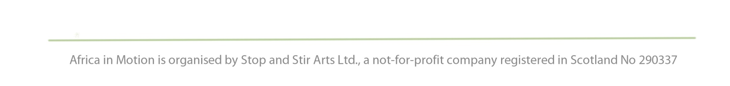
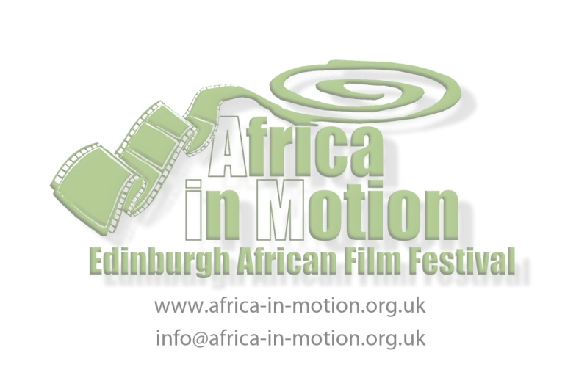
PRESS RELEASE
For immediate use: Wednesday 28 September 2011

FANTASTIC FILMS, STORYTELLLING, DRUMMING AND DANCING AT THE AFRICA IN MOTION CHILDREN’S DAY
Saturday 5 November 2011, 11am – 5pm
Filmhouse, 88 Lothian Road & St Cuthbert’s Parish Church, 5 Lothian Road

Join us for the Africa in Motion, the UK’s largest African film festival’s dedicated Children’s Day, featuring magical storytelling, a programme of short films and animations and drumming and dancing workshops.

The day starts at the Filmhouse at 11am with a free African storytelling event hosted by Kenyan/Scottish storyteller Mara Menzies of Toto Tales. Introducing fantastic characters from history and folklore, this fun, interactive session gives a flavour of the African nations, their people and their rich cultural heritage. Suitable for children aged 2+ and their carers. Free ticketed event (tickets available from Filmhouse Box Office).

African Films for Children, starting at 1pm (finishing at 2.45pm), is a specially curated programme of 7 films: 4 short animations, one animated feature and two short films. Featuring fantastic tales of adventure, stories based on Ethiopian and Maasai folklore and short films revealing powerful messages about survival and the natural environment, the programme will delight young audiences and their families. Suitable for children aged 6+ and their carers. English subtitles will be narrated for younger viewers.

Over at Lindisfarne Hall at St Cuthbert’s Parish Church – a short walk from the Filmhouse - (sessions starting at 2pm and 3.30pm), Drumming & Dancing workshops introduce young audiences to the music and rhythms of Africa. Feel the beat of the djembe drum, dance to the infectious rhythms and create your own compositions and routines in a relaxed, fun environment. Organised in collaboration with the Inspiration Festival in Glasgow. Suitable for children aged 7+ (Families welcome).

Africa in Motion is the UK’s largest African film festival. Now in its sixth consecutive year at the Filmhouse in Edinburgh, the Festival brings together the best in new cinema from Africa, classic films from the continent’s most celebrated filmmakers, award-winning documentaries, seminars, exhibitions and events.

The theme of this year’s festival is ‘Children & Youth in Africa’, bringing together the best new films with cinematic representations for, by and about children and young people both in the rural areas and urban centres of contemporary Africa.

As part of this year’s festival, we have asked school children from around the city of Edinburgh to offer us their photographs of travels and experiences in Africa. We present these wonderful images, in association with City of Edinburgh Council: Network Africa in a special exhibition in the Filmhouse café bar. City of Edinburgh Council: Network Africa encourages and facilitates schools’ exchange trips to English-speaking African countries.

Tickets for all Children’s Day events available from the Filmhouse Box Office (0131 228 2688; www.filmhousecinema.com)

For full programme information, see the website: www.africa-in-motion.org.uk

For more information about Africa in Motion Children’s Day and publicity images, please contact Catherine Bromley at Catherine@africa-in-motion.org.uk or call 07843 626 042.

Notes to Editors:

- Africa in Motion 2011 includes a programme of films screened as part of National Schools Film Week. For Primary and Secondary Schools only, these free screenings can be booked by Schools directly through the website: www.nationalschoolsfilmweek.org

- Africa in Motion on Tour sees the film festival travel to schools in Edinburgh, Fife and the Lothians in February 2012. We will screen films, talk to the children about Africa and teach them, through myths and stories from the most amazing places in Africa, about being a global citizen. For contact and booking information, please contact our Schools Events Coordinator Tanwen Llewelyn at tanwen@africa-in-motion.org.uk or call 07530 903 337.

