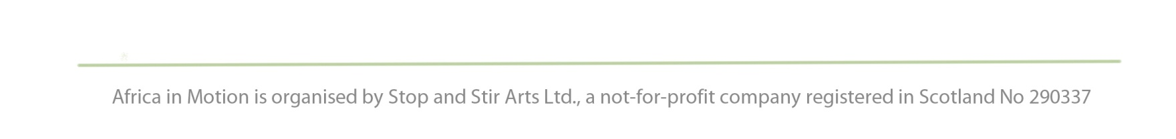
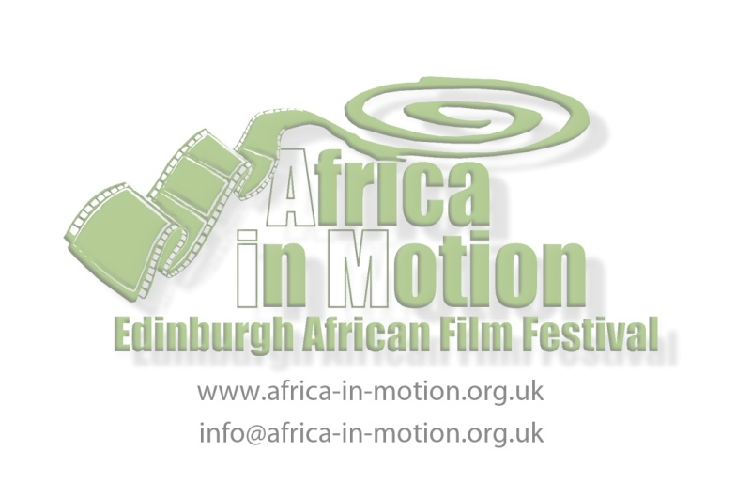
PRESS RELEASE
For immediate use

Africa in Motion (AiM) Documentary Screenings
reveal social issues and point to the future

The Africa in Motion (AiM) film festival, now in its 6th year, is playing host to a range of African documentary films at the festival this year, taking place from 2-6 November at Filmhouse cinema and other venues. Documentary filmmaking in Africa has a long tradition of being utilised as a way to raise awareness about pertinent social issues and this is reflected in the documentary programme through films addressing issues such as disability; domestic abuse; violence, trauma and reconciliation; girls’ education and female emancipation. The documentary form has also long been a medium to represent African from the outside, through National Geographic style films, but the documentary films in the Africa in Motion programme show how the genre is being applied by African filmmakers to tell their own stories and present their cultures, histories and hopes for the future from an insider’s perspective.

In line with the overarching festival theme “Children and Youth in Africa”, many of the documentaries in the programme focus specifically on children’s issues, drawing attention to the fact that children in Africa live through difficult as well as life-affirming circumstances. Offering a balanced and ultimately hopeful view on the future of children in Africa, these documentaries engage with issues concerning the children, the parent-child relationship, and all of us globally.

Two afternoons of free documentary screenings at the Edinburgh College of Art (in collaboration with the Scottish Documentary Institute), will introduce Edinburgh-based film students and cinephiles to some of the crucial social issues that African documentary filmmakers address in their films. Hidden Truth (Zambia) is a candid and intimate portrayal depicting the lives of women and children who survive domestic violence. Filmed by the first group of women filmmakers in rural Zambia, the film won the prize for Best Documentary at the 2011 Zanzibar International Film Festival. De corpo e alma (Body and Soul, Mozambique) follows the lives of three young Mozambicans with physical disabilities, and chronicles their physical, psychological and emotional challenges and victories. Waited For (South Africa) is a touching documentary that interweaves three stories of South African lesbian women who adopt across racial lines. Waliden (from Mali, the term refers to an adopted child in the Bambara language) is a plea for better treatment of adopted children. Le collier et la perle (The Necklace and the Bead, Senegal) is a beautiful and poetic filmed letter from a father to his daughter, exploring the mysteries of womanhood and giving birth.

In collaboration with the University of Edinburgh’s Centre for Theology and Public Issues’s (CTPI) project on 'Peace-building through Media Arts', the festival includes a series of documentaries offering examples of peace-building through film. Slaves (Sudan) is an animated documentary based on the testimonies of two Sudanese children who were taken by government-sponsored militia in Sudan and exploited as slaves. Fambul Tok (from Sierra Leone, meaning “family talk”), shows how this ancient communal practice is used to encourage victims and perpetrators of Sierra Leone’s brutal civial war to come together in a programme of tradition-based truth-telling and forgiveness ceremonies. Where Do I Stand? (South Africa) is a window into the lives of seven young South Africans grappling with their actions during the xenophobic attacks that broke out across South Africa in May 2008. State of Mind (Democratic Republic of the Congo, from the director of the highly acclaimed Viva Riva!) is a layered, engrossing and intriguing look at a national collective trauma and the ambitious initiative to try and heal its wounds.

For full programme details please visit www.africa-in-motion.org.uk.

Tickets are available from Filmhouse box office on 0131 228 2688 or www.filmhousecinema.com. Concessionary discounts and ticket deals are available.

- ENDS -
Notes to Editors

- The full documentary listings are:
African Social Documentaries
Thu 3 Nov, 3.00pm to 5.00pm
Room 017, Edinburgh College of Art, Lauriston Place, Edinburgh EH3 9DF
Free non-ticketed event, consisting of:

Hidden Truth - UK Premiere
Penelope Machipi · Zambia 2011 · 21m · English and Bemba with English subtitles · 15

PLUS

De corpo e alma (Body and Soul) - UK Premiere
Matthieu Bron · Mozambique 2011 · 56m · Portuguese with English subtitles · 15

---

African Documentaries about Children
Fri 4 Nov, 2.00pm to 5.00pm
Room 017, Edinburgh College of Art, Lauriston Place, Edinburgh EH3 9DF
Free non-ticketed event, consisting of:

Waited For - UK Premiere
Nerina Penzhorn · South Africa 2011 · 1h · 15

PLUS

Waliden, enfant d'autrui (Waliden: Children of Others) - UK Premiere
Awa Traoré · Mali 2009 · 52m · Bambara with English subtitles · 15

PLUS

Le collier et la perle (The Necklace and the Bead) - UK Premiere
Mamadou Sellou Diallo · Senegal/France 2009 · 52m · French and Wolof with English subtitles · 15

---

Slaves
Sat 5 Nov at 3.00pm
Filmhouse Cinema 2
David Aronowitsch · Sweden/Sudan 2010 · 15m · Swedish, English and Dinka with English subtitles · 15

Followed by

Fambul Tok
Sara Terry · Sierra Leone/USA 2010 · 1h22m · 15

---

Where do I Stand? - UK Premiere
Sat 5 Nov at 6.00pm
Filmhouse Cinema 2
Molly Blank · South Africa 2010 · 38m · English and Xhosa with English Subtitles · 15

Followed by

State of Mind - UK Premiere
Djo Tunda Wa Munga · Democratic Republic of the Congo/South Africa 2010 · 52m · French, Swahili and Lingala with English Subtitles · 15

- For press enquiries, please contact Gillian Cook on 07790 200 471 or gillian@africa-in-motion.org.uk
- Press releases, logos and publicity images are available to download from www.africa-in-motion.org.uk/press
- AiM is delivered by a management team: Lizelle Bisschoff (lizelle@africa-in-motion.org.uk), Isabel Moura Mendes (isabel@africa-in-motion.org.uk), Kari Ann Shiff (kari-ann@africa-in-motion.org.uk) and Stefanie Van de Peer.
- AiM is funded by Creative Scotland; Commonwealth Foundation; and British Film Institute Transition Fund (Africa in Motion Schools Tour). Sponsors are: Centre for Theology and Public Issues (CTPI), University of Edinburgh; School of Languages, Cultures and Religions, University of Stirling; Scottish Documentary Institute; Society for Francophone Postcolonial Studies; Centre of African Studies, University of Edinburgh; Wines of South Africa; and The Africa Channel (Short Film Competition).

